ASSIGNMENT 5 REPORT :

1.To get the intrinsic and extrinsic parameters the steps were followed:

1.I took the left camera picture in one folder ,and right camera pictures in other folder.I used the camera

Calibrator App and the load the 12 left camera images into the application with 25.4mm.For left camera I save as leftcameraparams.I saved the session into LeftcalibrationSession.mat .

2.I did the same for right camera images . I saved the session into rightcalibrationSession.mat .

3.I Ran the script Problem_1.m to find the intrinsic and extrinsic parameters.

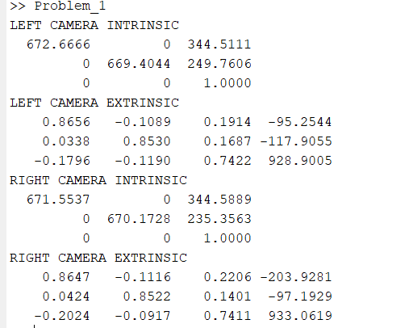

2.

For the implementation I selected window size 5 and chose the threshold 60 .Images are padded based on the size of the window.A patch is created for every pixel .and so as a strip from right side alse created.The search is done based on the threshold and we got the best disparity.

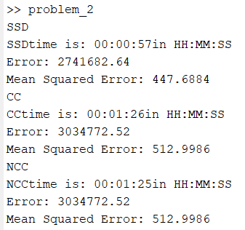

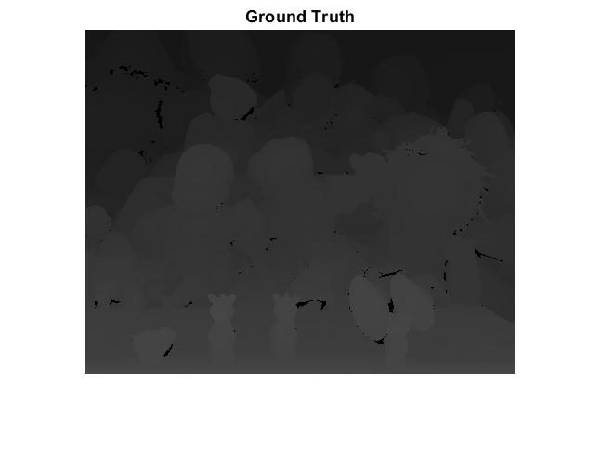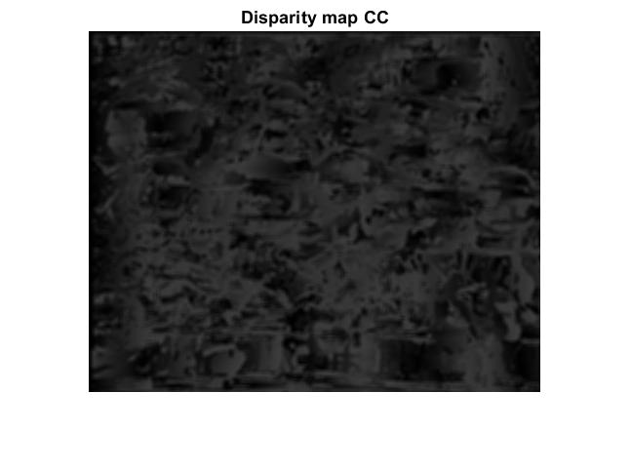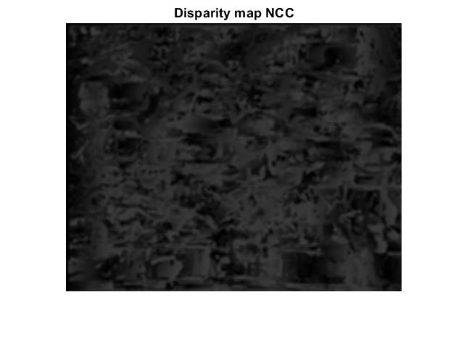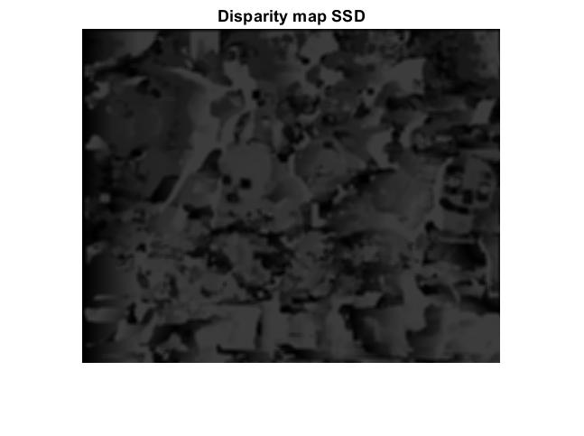

According to the figures ,it can be decided that SSD gives the best result.

3.

a)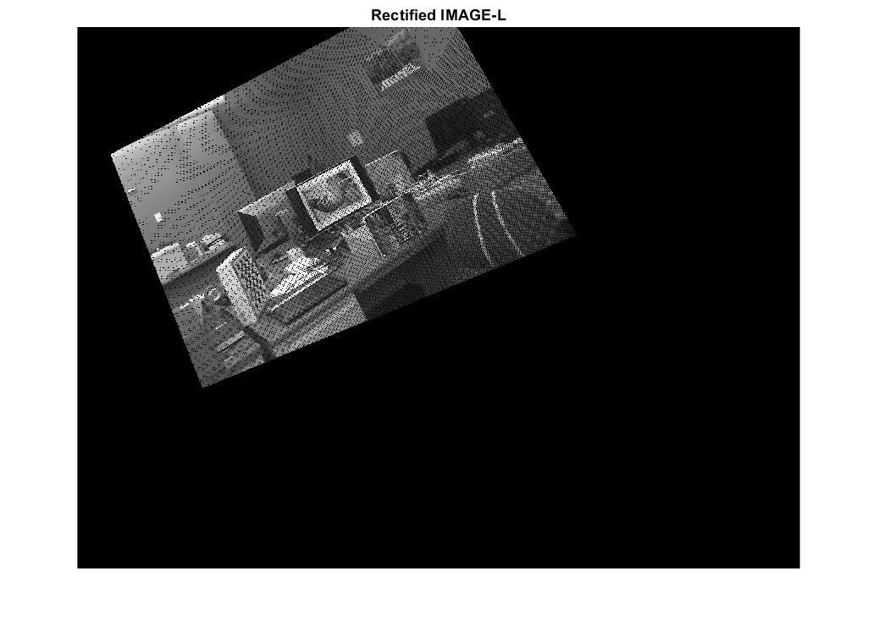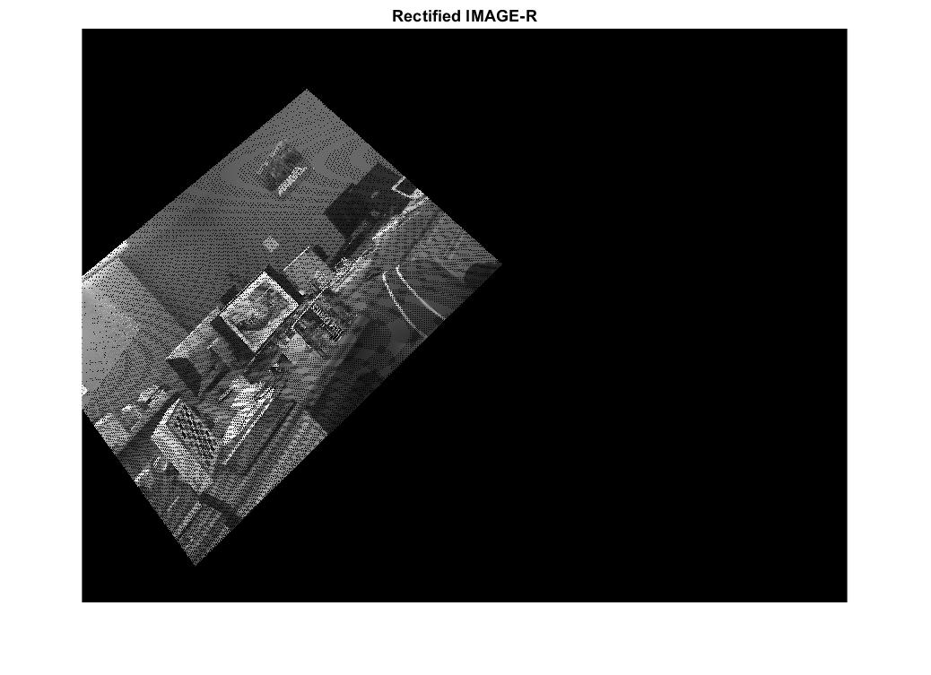

b)partially done

4.

Least square method :

Let us assume that the given points of data are (x_1, y_1), (x_2, y_2), …, (x_n, y_n) in which all x's are independent variables, while all y's are dependent ones. Also, suppose that f(x) be the fitting curve and d represents error or deviation from each given point.  
The least-squares explain that the curve that best fits is represented by the property that the sum of squares of all the deviations from given values must be minimum.

Custom Algorithm for removing outliers :

A self learning algorithm is used ,which follows neural networks.The best fit is calculated using least squared method ,and also the distance vector is calculated.the inliers are taken based on mean of d and standard deviation of d.and the best fit is computed.We repeat it until there is no change in the inliers for couple of continuos loops.

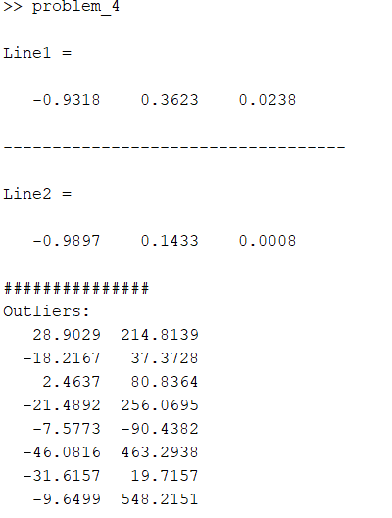

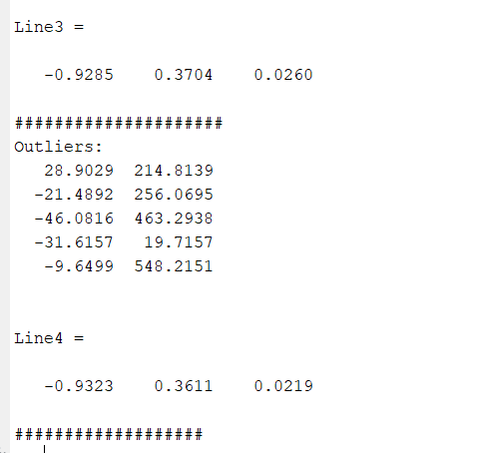

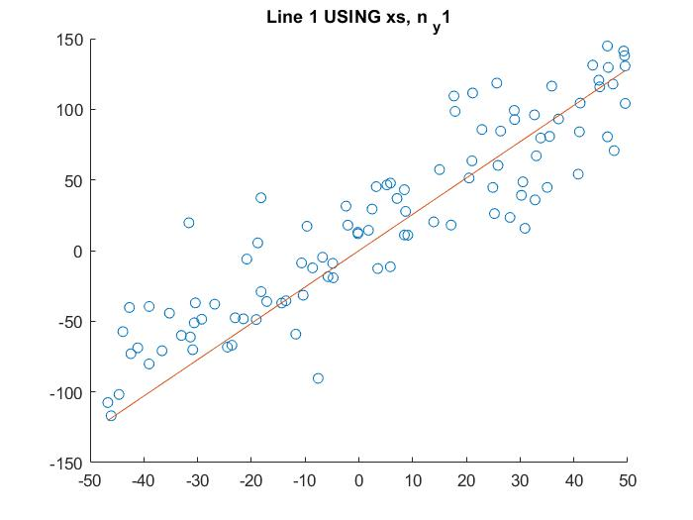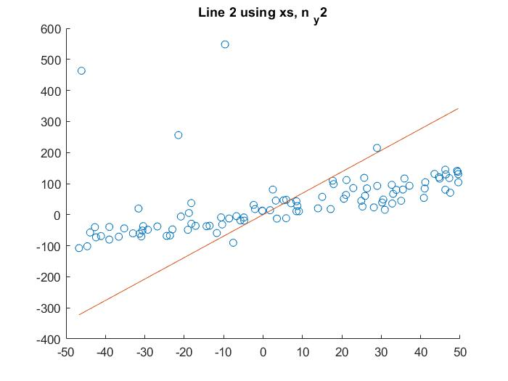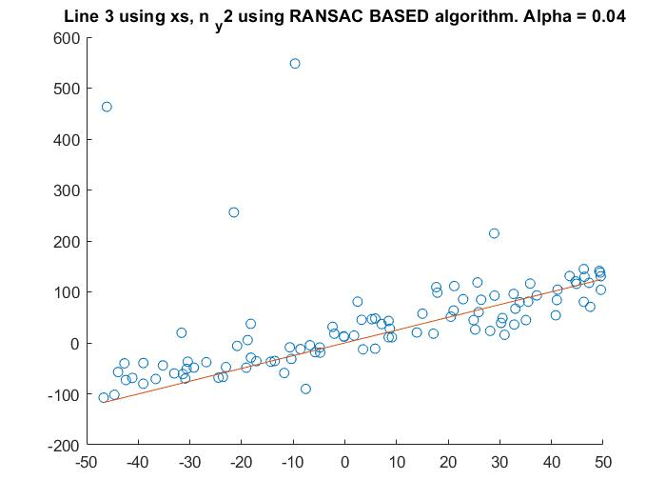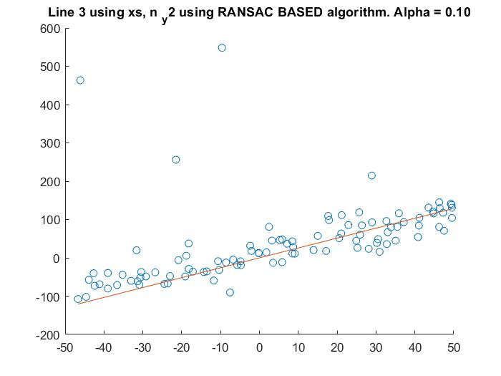

References:

1.https://www.youtube.com/watch?v=AGH19eJWunk

2.https://www.mathworks.com/help/vision/ug/camera-calibration.html

3.https://www.youtube.com/watch?v=GpU1Vx-b3VA&t=288s

4.https://www.youtube.com/watch?v=QqRBNbfwPII

5.https://drive.google.com/file/d/1_s2nZM6JPp566EmYdtEOCpcBUBeNMk5K/view

6.https://www.cs.auckland.ac.nz/~rklette/CCV-CIMAT/pdfs/B14-CameraCalibration.pdf

7.http://homepages.inf.ed.ac.uk/rbf/CVonline/LOCAL_COPIES/FUSIELLO2/node5.html

8. http://www.sci.utah.edu/~gerig/CS6320-S2012/Materials/CS6320-CV-F2012-Rectification.pdf

9. http://www.cim.mcgill.ca/~langer/558/19-cameracalibration.pdf

10.http://www.sci.utah.edu/~gerig/CS6320-S2012/Materials/CS6320-CV-F2012-Rectification.pdf

11.https://link.springer.com/article/10.1007/s11042-018-6475-6

12.https://www.youtube.com/watch?v=zIeX8bqKSBs